**LAPORAN TUGAS PEMROGRAMAN KOMPUTER KELOMPOK 4 (PROGRAM PENDATAAN JASA TITIP LUAR NEGERI)**

**1. Penjelasan Singkat Program dan Algoritma**

Program aplikasi pendataan jasa titip luar negeri dirancang khusus bagi pengguna yang memiliki usaha jasa titip barang dari luar negeri. Dengan adanya program ini, diharapkan pelaku jastip lebih mudah, cepat, dan efisien dalam merekap transaksi pesanan dari pembeli yang berada di Indonesia. Untuk menghindari kesalahan dalam pembelian barang oleh pelaku jastip, program aplikasi ini mampu mengelompokkan pesanan berdasarkan jenis barang dan negara tujuan barang yang dipesan oleh *customer.* Selain itu, tersedia juga layanan konversi mata uang, sehingga pelaku jastip tidak perlu kesulitan dalam mengonversi mata uang luar negeri ke rupiah. Beberapa fitur yang ditawarkan oleh program ini, yaitu :

1. Melakukan pencatatan pesananAnda
2. Melihat pesanansecara langsung
3. Menyimpan database pesanan dan pelanggan dalam bentuk csv/excel

Alur dari program yang telah dibuat adalah sebagai berikut.

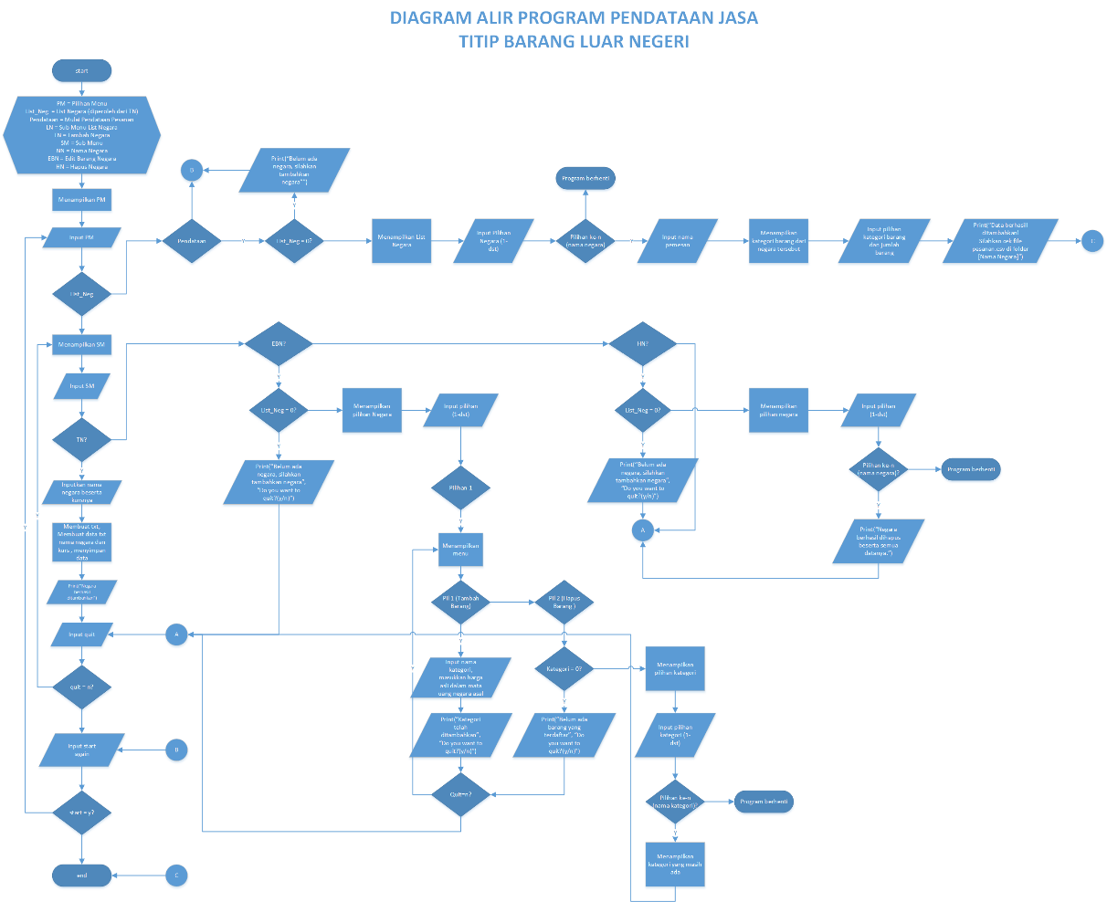

**2. Python Code**

**Person.py**

|  |
| --- |
| import os  class Person:  _person_name = ""  _name_kategori_file = ""  def __init__(self, country, person_name):  # create folder if not exist  if not os.path.exists(country):  os.makedirs(country)  self._person_name = country  self._name_kategori_file = os.path.join(country, person_name + ".txt")  # create file first if not exist  __file = open(self._name_kategori_file, "a")  __file.close()  def add_product(self, product, amount):  if product not in self._get_list_product():  __file = open(self._name_kategori_file, "a")  __file.write(product + "," + str(amount) + "\n")  __file.close()  else:  print("Produk sudah ditambahkan")  def get_raw_product(self):  __file = open(self._name_kategori_file, "r")  return __file.readlines()  def _get_list_product(self):  __file = open(self._name_kategori_file, "r")  list_beli = __file.readlines()  for index, item in enumerate(list_beli):  list_beli[index] = item.split(",")[0]  return list_beli    def delete_product(self,product_name):  if product_name in self._get_list_product():  index_product = self._get_list_product().index(product_name)  list_raw = self.get_raw_product()  del list_raw[index_product]  self._update_product(list_raw)    def _update_product(self, list_product):  __file = open(self._name_kategori_file, "w")  __file.writelines(list_product)  __file.close() |

**Barang.py**

|  |
| --- |
| import os  import shutil  from Person import Person  class BarangJual:  _name_kategori_file = ""  _country_name = ""  def __init__(self, country):  # create folder if not exist  if not os.path.exists(country):  os.makedirs(country)  self._country_name = country  self._name_kategori_file = os.path.join(country, "barang.txt")  # create file first if not exist  __file = open(self._name_kategori_file, "a")  __file.close()  def switch(self, kode):  return getattr(self, "_menu_" + str(kode), lambda: self._default)()  def listBarang(self):  print("Daftar kategori : ")  kategori = self.get_kategori()  if len(kategori) != 0:  for index, text in enumerate(self.get_kategori()):  print("\t" + str(index + 1) + ". " + text)  else:  print("Kategori kosong")  def _menu_1(self):  name = input("Masukkan nama kategori : ")  harga = float(input("Masukkan harga(" + self._country_name + ") : "))  if self._add_kategori(name, harga):  print("Kategori telah di tambahkan :")  for index, text in enumerate(self.get_kategori()):  print("\t" + str(index + 1) + ". " + text)  print("\n")  else:  print("Kategori sudah ada")  def _menu_2(self):  if len(self.get_kategori()) != 0:  index_barang = int(input("Pilih barang yang ingin di hapus: ")) - 1  list_raw = self.get_raw_kategori()  list_person = self._get_list_person(self._country_name)  if len(list_person)!=0:  for person in list_person:  Person(self._country_name,person.replace("\n","")).delete_product(self.get_kategori()[index_barang])  del list_raw[index_barang]  self._update_barang(list_raw)  self.listBarang()    else:  print("Belum ada barang yg terdaftar")  def _default(self):  print("invalid code, pick again")  def _update_barang(self, list_barang):  __file = open(self._name_kategori_file, "w")  __file.writelines(list_barang)  __file.close()  def get_raw_kategori(self):  __file = open(self._name_kategori_file, "r")  return __file.readlines()  def get_kategori(self):  __file = open(self._name_kategori_file, "r")  list_barang = __file.readlines()  for index, barang in enumerate(list_barang):  list_barang[index] = barang.split(",")[0]  return list_barang  def delete_country(self):  shutil.rmtree(self._country_name)  def _add_kategori(self, kategori, harga):  if len(self.get_kategori()) == 0 or kategori not in self.get_kategori():  __file = open(self._name_kategori_file, "a")  __file.write(kategori + "," + str(harga) + "\n")  __file.close()  return True  else:  return False    def _get_list_person(self,country_name):  _file = open(os.path.join(country_name, "person.txt"),"a+")  _file.seek(0)  return _file.readlines() |

**MenuNegara.py**

|  |
| --- |
| from os import system  from Barang import BarangJual  class MenuNegara:  def __init__(self):  __file = open("country_list.txt", "a")  __file.close()  def switch(self, kode):  return getattr(self, "_menu_" + str(kode), lambda: self._default)()  def _default(self):  print("invalid code, pick again")  def _menu_1(self):  system("cls")  country_name = input("Masukkan nama negara : ")  country_kurs = float(input("Masukkan nilai kurs ke INA : "))  if country_name not in self.listNegara():  __file = open("country_list.txt", "a")  __file.write(country_name + "," + str(country_kurs) + "\n")  __file.close()  print("Berhasil menambahkan negara")  else:  print("Negara sudah ada")  def _menu_2(self):  system("cls")  if len(self.listNegara())!=0:  print("Pilih Negara yang ingin di edit barangnya: ")  for index, country in enumerate(self.listNegara()):  print("\t" + str(index + 1) + ". " + country)  index_country = int(input("Pilihan : ")) - 1  iterasi = True  while iterasi:  self._menuEditBarangNegara(index_country)  iterasi = True if input("do you want to quit? (y/n)") == "n" else False  else:  print("Negara belum ada, silahkan menambahkan negara terlebih dahulu")  def _menu_3(self):  system("cls")  if len(self.listNegara()) != 0:  print("Pilih Negara yang ingin di hapus: ")  for index, country in enumerate(self.listNegara()):  print("\t" + str(index + 1) + ". " + country)  index_country = int(input("Pilihan : ")) - 1  list_raw = self.get_raw_country()  barang_country = BarangJual(self.listNegara()[index_country])  barang_country.delete_country()  del list_raw[index_country]  self._update_country(list_raw)  print("Berhasil menghapus negara beserta semua datanya")  else:  print("Negara belum ada, silahkan menambahkan negara terlebih dahulu")  def _update_country(self, list):  __file = open("country_list.txt", "w")  __file.writelines(list)  __file.close()  def get_raw_country(self):  __file = open("country_list.txt", "r")  return __file.readlines()  def listNegara(self):  __file = open("country_list.txt", "r")  country_list = __file.readlines()  __file.close()  for index, country in enumerate(country_list):  country_list[index] = country.split(",")[0]  return country_list  def _menuEditBarangNegara(self, index_country):  print("\n")  menu_barang = BarangJual(self.listNegara()[index_country])  menu_barang.listBarang()  print("1. Tambah Barang")  print("2. Hapus Barang")  code_menu = input("Pilihan : ")  menu_barang.switch(code_menu) |

**MenuPesanan.py**

|  |
| --- |
| import csv  import os  from os import system  from Barang import BarangJual  from MenuNegara import MenuNegara  from Person import Person  class MenuPesanan:  _country_name = ""  _file_person_name = ""  _file_pesanan_csv = ""  def __init__(self, country):  self._file_person_name = os.path.join(country, "person.txt")  self._file_pesanan_csv = os.path.join(country, "pesanan.csv")  _file = open(self._file_person_name, "a")  _file.close()  self._country_name = country  def switch(self, kode):  return getattr(self, "_menu_" + str(kode), lambda: self._default)()  def _default(self):  print("invalid code, pick again")  def _menu_1(self):  name_person = input("Masukkan nama pemesan : ")  if (name_person+"\n") not in self.get_list_person():  _file = open(self._file_person_name, "a")  _file.write(name_person + "\n")  _file.close()  produk_iterasi = True  while produk_iterasi:  system("cls")  print("\tPesanan untuk " + name_person)  menuBarang = BarangJual(self._country_name)  menuPerson = Person(self._country_name, name_person)  print("Pilih Produk :")  for index, product in enumerate(menuBarang.get_kategori()):  print(str(index + 1) + ". " + product)  index_product = int(input("Pilihan : ")) - 1  jumlah_barang = int(input("Jumlah barang : "))  menuPerson.add_product(menuBarang.get_kategori()[index_product], jumlah_barang)  print("Berhasil menambahkan data!")    with open(self._file_pesanan_csv, mode="w", newline="") as _file_open:  _header = ["No", "Nama", "Barang", "Harga Barang", "Jumlah", "Total Harga(" + self._country_name + ")",  "Total Harga(INA)"]  _writer = csv.DictWriter(_file_open, _header)  _writer.writeheader()  _count = 1  for index, name in enumerate(self.get_list_person()):  _name = name.replace("\n", "")  menuPerson = Person(self._country_name, _name)  for index, product in enumerate(menuPerson.get_raw_product()):  _item = product.split(",")[0]  _amount = product.split(",")[1].replace("\n", "")  menuBarang = BarangJual(self._country_name)  _index_barang = menuBarang.get_kategori().index(_item)  _price = menuBarang.get_raw_kategori()[_index_barang].split(",")[1].replace("\n", "")  menuNegara = MenuNegara()  index_negara = menuNegara.listNegara().index(self._country_name)  _kurs = menuNegara.get_raw_country()[index_negara].split(",")[1].replace("\n", "")  _input = {  "No": _count,  "Nama": _name,  "Barang": _item,  "Harga Barang": _price,  "Jumlah": _amount,  "Total Harga(" + self._country_name + ")": float(_price) * int(_amount),  "Total Harga(INA)": float(_price) * int(_amount) * float(_kurs)  }  _writer.writerow(_input)  _count += 1  print("\tCetak list pesanan berdasarkan")  print("\tSilahkan cek file pesanan.csv di folder [" + self._country_name + "]")  produk_iterasi = True if input("ingin menambah barang lagi?(y,n)") == "y" else False  def get_list_person(self):  _file = open(self._file_person_name, "r")  return _file.readlines() |

**main.py**

|  |
| --- |
| from os import system  from MenuPesanan import MenuPesanan  from MenuNegara import MenuNegara  class MainMenu:  def switch(self, kode):  return getattr(self, "_menu_" + str(kode), lambda: self._default)()  def _default(self):  print("invalid code, pick the correct code")  def _menu_1(self):  print("\n\n")  _iterasi = True  menuNegara = MenuNegara()  while _iterasi:  system("cls")  print("\tNegara JasTip")  if len(menuNegara.listNegara()) != 0:  for index, country in enumerate(menuNegara.listNegara()):  print(str(index + 1) + ". " + country)  else:  print("--Masih Kosong--")  print("Pilih Menu:")  print("\t1. Tambah Negara\n"  "\t2. Edit Barang Negara\n"  "\t3. Hapus Negara")  menu_code = int(input("PIlihan : "))  menuNegara.switch(menu_code)  _iterasi = True if (input("do you want to quit?(y/n) ") == "n") else False  def _menu_2(self):  print("\n\n")  menuNegara = MenuNegara()  if len(menuNegara.listNegara()) == 0:  print("Belum ada negara yg terdaftar, silahkan menambahkan negara terlebih dahulu")  else:  iterasi = True  while iterasi:  system("cls")  print("\tJasa Titip Antar Negara")  for index, country in enumerate(menuNegara.listNegara()):  print(str(index + 1) + ". " + country)  index_country = int(input("Pilih negara tujuan : ")) - 1  print("\n")  print("\t JasTip Negara " + menuNegara.listNegara()[index_country] + "\n")  menu_code = 1  menu_pesanan = MenuPesanan(menuNegara.listNegara()[index_country])  menu_pesanan.switch(menu_code)  iterasi = True if (input("do you want to quit?(y/n) ") == "n") else False  if __name__ == "__main__":  menu = MainMenu()  iterasi = True  print("------------------------------------------------------------------------------")  print("----------SELAMAT DATANG DI PENDATAAN JASA TITIP BARANG LUAR NEGERI-----------")  print("------------------------------------------------------------------------------")  while iterasi:  print("\tPilihan menu")  print("\t 1. List Negara\n"  "\t 2. Mulai Pendataan Pesanan")  menu_kode = int(input("Pilih menu : "))  menu.switch(menu_kode)  iterasi = True if (input("start again?(y/n) ") == "y") else False |